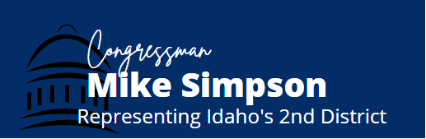
FY2022 Defense Appropriations Community Project Request Form
Return completed form and required documentation through the Community Project Request webform found here.
Due Date: April 12, 2021

Note: Projects can only be designated for state and local governments or certain eligible non-profit entities. Projects cannot be designated for private individuals or for-profit entities. Submissions must include proof of community support. The Subcommittee will only accept legally eligible requests under DOD Research, Development, Test and Evaluation (RDTE) accounts: RDTE Army, RDTE Navy, RDTE Air Force, RDTE Space Force, RDTE Defense-Wide. If you have questions about the appropriations community project submission process, please contact Simpson.appropriations@mail.house.gov to discuss.

Entity Requesting Funds (if entity is a non-profit, please include documentation that the entity is registered as a 501(c)3 under the Internal Revenue Code of 1986):

Primary Point of Contact (name, email, phone number, organization address):

Project Priority (if non-federal sponsor is submitting more than 1 project):

Short Description of the project:

Complete Description of Project, its desired outcome, and how it would benefit the Department of Defense (limit 1000 characters, including spaces):

List the eligible account proposed to fund the project (Ex: RDTE, Army):

List the Line Number & Program Element Number (& Program Name if applicable) proposed to fund the project (Example: Line 2, PE# 0601102A):

(Note: The appropriate line and program element numbers must be included with your submission. If you do not know this information, please consult with the relevant DOD program office. This information may also be located through the Department’s FY2021 RDTE budget justification documents posted at: https://comptroller.defense.gov/Budget-Materials/Budget2021/. FY2022 documents will be obtainable after the FY2022 full budget rollout, through the Under Secretary of Defense (Comptroller) website: https://comptroller.defense.gov/Budget-Materials/.)

Requested FY22 Amount, including level of funding over the President’s FY22 Budget Request:

Has this project been requested in any other bill? If so, which bill?

Has this project been submitted to any other Member of Congress, if so please list the Members’ name and a staff point-of-contact:

Is this project a new or existing project?

If an existing project, has the project previously received federal funds?

If yes, please list the sources and amounts of funding previously provided and in which fiscal year the funds were provided:

Total Project Cost (including breakdown of federal/non-federal shares):

List the required funding in future years and the sources of that funding:

Can the project begin in a limited capacity if the Appropriations Committee cannot fully fund the request?

If yes, please provide documentation that the project can begin in a limited capacity if the Appropriations Committee cannot fully fund the request:

__________________________________________________________________________________________________

Additional guidance on Community Project Funding requests for eligible accounts:

Proof of Community Support
All submissions may include but are not limited to:
- Letters of support from elected community leaders;
- Press articles highlighting the need for the requested community project funding;
- Support from newspaper editorial boards;
- Projects listed in state intended use plans, community development plans, or other publicly available planning documents;
- Resolutions passed by city councils or boards; and/or
- Other compelling evidence of community support.

