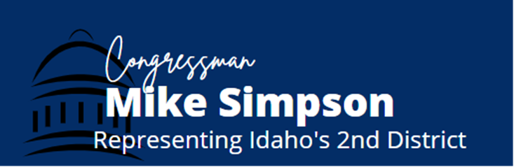
FY2022 Financial Services Appropriations Community Project Request Form
Return completed form and required documentation through the Community Project Request webform found here.
Due Date: April 12, 2021

Note: Only non-profit entities, public institutions, and state and local government entities are eligible to request projects. Projects cannot be designated for private individuals or for-profit entities. Submissions must include proof of community support. The Subcommittee will only accept legally eligible requests under the following account: Small Business Administration, Small Business Initiatives. Eligible projects include projects in support of small businesses, such as entrepreneur training, workforce development, counseling, research, and construction or acquisition of facilities. If you have questions about the appropriations project review process, please contact Simpson.appropriations@mail.house.gov to discuss.

Entity Requesting Funds (full legal name, no abbreviations):

If a non-profit, please provide documentation that the organization is registered as a 501(c)(3) under the Internal Revenue Code of 1986.

Primary Point of Contact (name, email, phone number, organization address):

Project Location, if different from organization location:

Project Priority (if non-federal sponsor is submitting more than 1 project):

Short description of the project to appear in the report:

Requested Amount:

Has this project been submitted to any other Members of Congress? If so, which Member(s) and who is the staff point-of-contact:

Complete Description of Project, including purpose and benefits provided by the Community Project (limit 1000 characters, including spaces):

Please include documentation of community support (examples: Letters of support from elected community leaders (e.g. mayors or other officials); press articles highlighting the need for the requested Community Project Funding; support from newspaper editorial boards; evidence the project is listed on State intended use plans, community development plans, or other publicly available planning documents); resolutions passed by city councils or boards):

Why is the project a priority, including the local, regional, and/or national benefits provided by the project?

What is the total cost of the project? Please include funding requested broken out by discrete activity, if applicable.

If the request does not fully fund the project, describe where the remaining funding comes from to fund the project.

If the appropriations committee is not able to provide the full amount of funding requested, can
this project start in a limited capacity? {yes/no}

Is this a new or ongoing project?

Please provide a history of funding for the project, including Federal, state, or local government; non-profit; corporate.

Are there matching funds associated with the requested funds? If yes, please list the source(s) and amount(s).

Will the funds go to an organization that will make sub-grants of those funds to other organizations? If yes, please list the sub-grantees, and provide full contact information for each.

Is the project a capital project or will the funds support operating costs?

Provide the oversight and management structure, including accountability measures, of the project. Who will oversee and be accountable for the administration/management of the project?

What performance standards will be used to evaluate whether the program or project supported by the funds meets its mission?

Has the organization or any potential sub-grantees been subject to sanction or litigation by State, Local, or Federal governments in the past five years? If so, please provide details.

__________________________________________________________________________________________________

Additional guidance on Community Project Funding requests for eligible accounts:

Proof of Community Support
All submissions may include but are not limited to:
- Letters of support from elected community leaders;
- Press articles highlighting the need for the requested community project funding;
- Support from newspaper editorial boards;
- Projects listed in state intended use plans, community development plans, or other publicly available planning documents;
- Resolutions passed by city councils or boards; and/or
- Other compelling evidence of community support.

